Ntsako Baloyi,

19342975

Database ***

Assignment 1

Question 1

**Database Administrator:**

This person or a group of people are responsible for making the schema of the database. They also control everything that is happing on the database. The Database Administrator is also able to create accounts and records on the database and given user permissions to access the database.

**Naive End Users:**

These are the people who do not have any knowledge on databases but are frequently getting data from the database using applications.

**Database Designers:**

They are the user that design the basic structure of a database. Designers make the tables, indexes, views, etc. They control what data goes into the database

**Casual Users:**

These users access the database every now and then not always. These users are the managers for example, they may get data from the database when they are doing a regular check.

**System Analyst:**

System analyst check if the end users are satisfied after interacting with the database.

Question 2

Q.2.1.1 When we have a one-to-many relationship, one record in one table can be associated with one or many records in the other table. E.g., A ProductID can be used in one table to identify the products sold and the ProductsSold table.

Q.2.1.2 When there is a many-to-many relationship many records in a table are associated with many records in another table. E.g., A module can be associated with one or many subjects but many modules can relate to many subjects.

Q.2.1.3 The one-to-one relationship is when one record in a table match only one record in the other table. E.g., a product can relate to one product in another table when trying to find it.

Q.2.2.1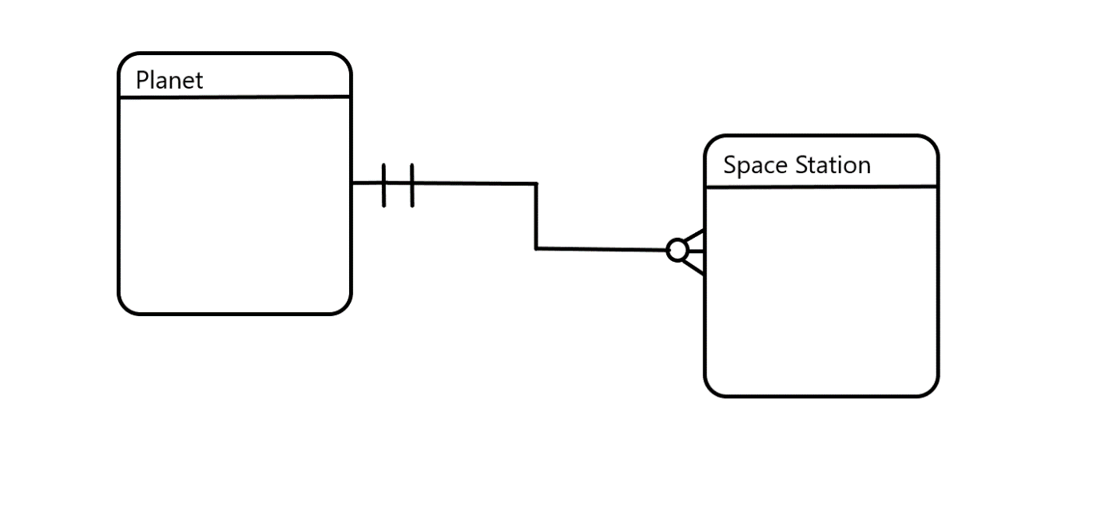

Q.2.2.2 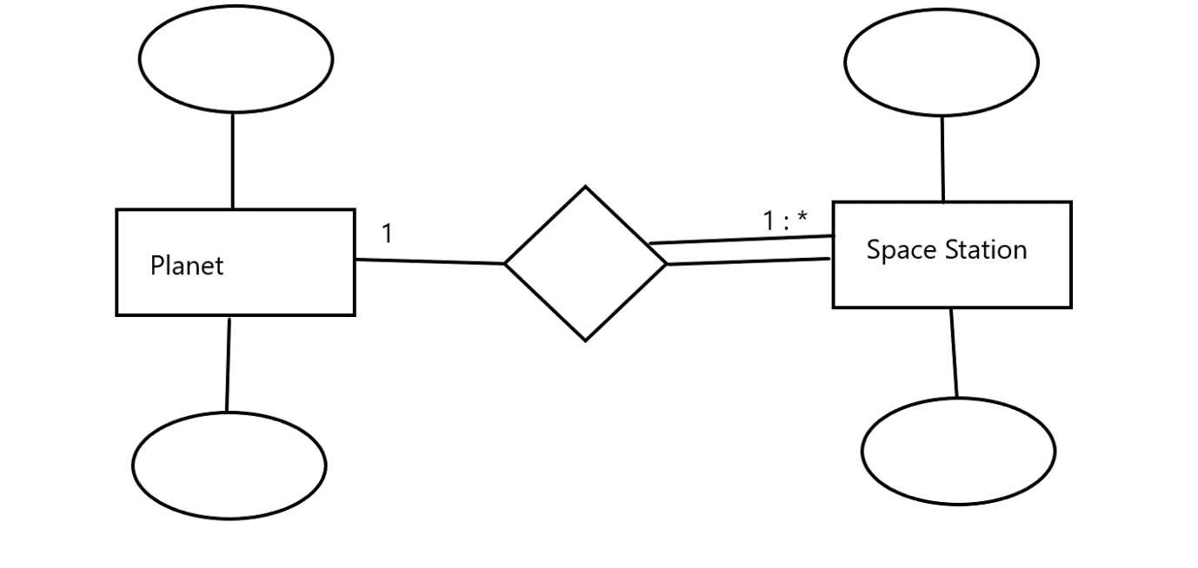

Q.2.2.3 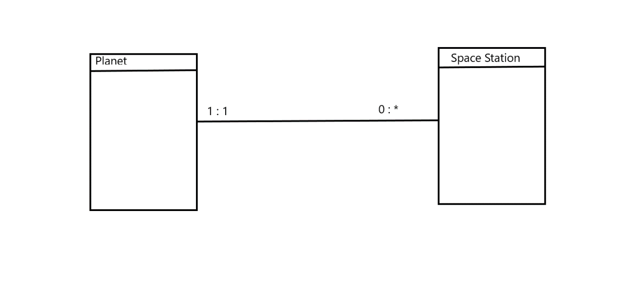

Q.2.3.1 A foreign key is a primary key that is found in two or more tables.

Q.2.3.2 Foreign keys are used to link data that is related in a database, by doing this we ensure that the data is consistent and we don’t have redundant data.

Question 3

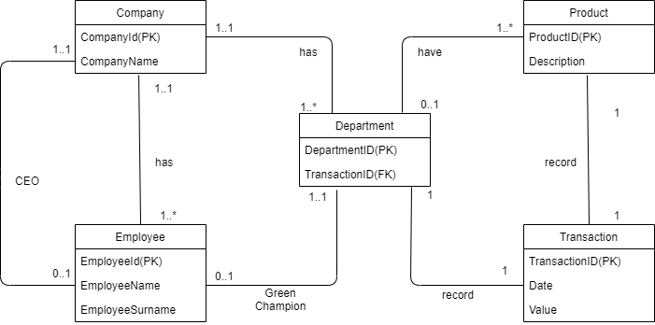

Question 4

* The multiplicities need to be added to the diagram for the product, parts, the bridge entity and the producer.
* Add a primary key for the producer.
* Give the bridge entity between the product and part a name.
* Add a primary key to the bridge entity.
* Add a description field for the product.
* Add an attribute to the bridge entity to help describe it further.
* Include the relationship name between the bridge entity and the part entity.
* Remove the Supplier ID primary key on the part entity or change it to a foreign key.
* Write the description between the bride entity and the Part entity.
* Add a multiplicity between Producer and Part.

Question 5

Q.5.1.1 **Data anomaly** – this is a result of data redundancy when we try to update or change a record but instead multiple records are altered.

Q.5.1.2 **Insertion anomaly –** this is when you are unable to add data to a table. This happens because there might be a value missing.

Q.5.1.3 **Deletion anomaly –** This might happen because we want to try and delete a record but instead, we delete multiple records that we did not plan on deleting.

Q.5.2 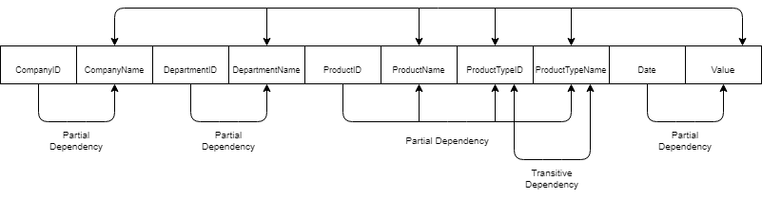

Q.5.3 Tshepo did not have an attribute describing the product and the accountant had one. It would be good to have this attribute because it can help describe a product on what type of product it is.

Secondly, the accountant’s data has the ability to record the date of the product and its value. Tshepo’s business rule do not record the date and the value of a product. It would be better to be able to get the date and the value because it will help with the data integrity.

Q.5.4 Product Table

|  |  |
| --- | --- |
| **ProductID** | **ProductName** |
| 1 | VR1000 |
| 2 | MC9 |
| 3 | AR26 |

Product Type

|  |  |
| --- | --- |
| **ProductType** | **ProductTypeName** |
| 1 | Headset |
| 2 | Camera |
| 1 | Headset |

Assignment

|  |  |  |
| --- | --- | --- |
| **ProductID** | **ProductTypeID** | **ProductTypeName** |
| 1 | 1 | Headset |
| 2 | 2 | Camera |
| 3 | 1 | Headset |

References

GeeksForGeeks

Question 1 - <https://www.geeksforgeeks.org/different-types-of-database-users/>

Question 2- https://fmhelp.filemaker.com/help/18/fmp/en/index.html#page/FMP_Help%2Fone-to-one-relationships.html%23

- https://fmhelp.filemaker.com/help/18/fmp/en/index.html#page/FMP_Help%2Fone-to-many-relationships.html%23

- <https://fmhelp.filemaker.com/help/18/fmp/en/index.html#page/FMP_Help%2Fmany-to-many-relationships.html%23>

Q.2.3.2 <https://www.eukhost.com/blog/webhosting/whats-the-purpose-use-primary-foreign-keys/#:~:text=Essentially%2C%20primary%20and%20foreign%20keys,the%20redundant%20data%20is%20removed>.

Question 5: https://databasemanagement.fandom.com/wiki/Category:Data_Anomalies#:~:text=An%20update%20anomaly%20is%20a,student%20group%20they%20participate%20in.